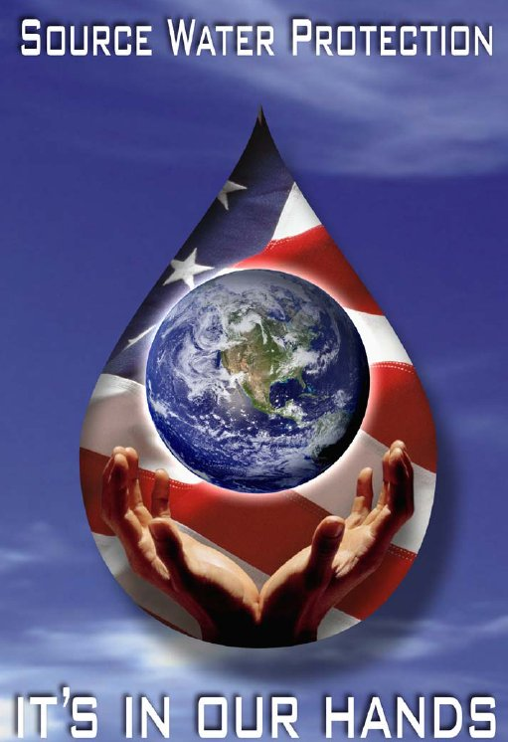
Source Water Protection Plan
For the
Name of water system
PWSID# 0000xxx
Update Month 2005
TECHNICAL ASSISTANCE
PROVIDED BY



Table of Contents

Source Water Protection Plan 1
Notification Roster 3
Contingency Plan 4
Critical Zone and Protection Zone 7
Source Water Protection Area 8
Aerial Photograph 9
Potential Contaminant Source Inventory 10
Intake Pictures 12
Updates 14
Appendix A 15
Appendix B 16

Source Water Protection Plan
Name of water system
P.W.S.I.D. NO. 0000xxx

The Name of water system has developed the following written policy to protect its Source Water Protection Area and Management Areas.

- The Name of water system will not store, nor allow to be stored, any chemicals within the Intake Structure of the Source Water Protection Area except for those chemicals used in the water treatment process.

- The Name of water system will not allow chemicals to be applied to the land within a minimum of 50 feet of their intake. Signs will be placed near the Name of water system property that contains their intake which read “Source Water Protection Area - Use chemicals according to the manufacturer’s label”. See Appendix A.

- In order to increase its available resources, the water system has furnished copies of the approved Source Water protection plan to the following agencies to solicit support in implementing the Source Water protection plan from these entities and to request review authority over any future changes to zoning laws and regulations which may affect the Source Water protection areas:
Table 1
Agencies
Agency | Contact Name

- The Name of water system will actively observe the activities within the designated Source Water Protection Area and report pertinent information to the Division of Water Resources Drinking Water Unit.

- The Name of water system will update the Potential Contaminant Source Inventory when changes occur within the Source Water Protection Area.

- The Name of water system will update the Source Water Protection Plan no less than every three (3) years by reviewing the Source Water protection areas at least annually for any new potential contaminant sources. Each annual review will be maintained on file for the Sanitary Survey.

- The Name of water system will publish in their Consumer Confidence Report the required information concerning their Source Water Protection Plan to provide public education.

- A Contingency Plan will be developed to establish the procedures to be implemented in the case of an emergency spill, which could impact the water source or the Source Water Protection Area. This Contingency Plan is included in the Source Water Protection Plan. In the case of an emergency spill which could impact the water source within the Source Water Protection Area, the Name of water system will contact:

Division of Water Resources Drinking Water Unit
at (615) 532-0191
within 72 hours

Tennessee Emergency Management Agency
at 1-800-262-3300
within 24 hours

- Water System Information:
Table 2
^{Source Water Contact Person} | ^{Position} | ^{Contact Phone Number} | ^{Contact e-mail}

 |  | TN
^{911 Address of Water Plant} | ^{City} | ^{State} | ^{Zip Code} | ^{County}

 |  | TN
^{Mailing Address of Water Plant} | ^{City} | ^{State} | ^{Zip Code} | ^{County}

Notification Roster
In the event a spill is reported to TEMA or the State of Tennessee, The phone numbers below can be used to contact the personnel at the Name of water system.
Table 3
Contact Name/Position | Phone Number #1 |  | Phone Number #2
 |  | ◻ Cell  ◻ Work  ◻ Home |  | ◻ Cell  ◻ Work  ◻ Home
 |  | ◻ Cell  ◻ Work  ◻ Home |  | ◻ Cell  ◻ Work  ◻ Home
 |  | ◻ Cell  ◻ Work  ◻ Home |  | ◻ Cell  ◻ Work  ◻ Home
 |  | ◻ Cell  ◻ Work  ◻ Home |  | ◻ Cell  ◻ Work  ◻ Home
 |  | ◻ Cell  ◻ Work  ◻ Home |  | ◻ Cell  ◻ Work  ◻ Home

Contingency Plan
Name of water system
P.W.S.I.D. NO. 0000xxx

Contingency Planning information provided by Name of water system is available in the State approved Emergency Plan and includes most items addressed below:

- Sources of drinking water currently available to the Public Water Supply:
  - The Name of water system utilizes the following water sources to supply drinking water to their customers:
Table 4
Water Sources

  - The Name of water system is connected to following water systems and would purchase water in the event of an emergency or spill within the Source Water Protection Zone.
Table 5
Emergency Connections

  - In the case of failure of the water sources, the emergency procedures addressed in the emergency response plan will be utilized.

  - The Name of water system currently serves Enter number of water connections here.

- Quantity of water available from currently connected sources:
The water sources providing water for the Name of water system have an estimated maximum output:
Table 6
Source Name | GPM

- Additional water supplies that will meet future needs:
  - There are no written plans for future water supplies.
  - Other: Explain: Explain the plans for the addition of future water sources

- Actions that have been taken by local governments to protect designated future water supplies:
  - The local governments have taken no action to protect future water supplies.
  - The Name of water system has furnished copies of the approved Source Water protection plan to agencies listed in Table 1(on page 1) of the Source Water Protection Plan to solicit support in implementing the Source Water protection plan from these entities and to request review authority over any future changes to zoning laws and regulations which may affect the Source Water protection areas.

- Protection plans for designated future water supplies:
  - The Source Water Protection Plan developed by the Name of water system prevents any chemicals not used for drinking water treatment from being stored adjacent to the intake. Also, signs will be placed on the fences surrounding the plant and raw water intake which read “Source Water Protection Area – Use chemicals according to the manufacturer’s label”. The Name of water system monitors activities within this area and reports pertinent information to the Division of Water Resources Drinking Water Unit.

- Schedule for incorporation of designated future water supplies into the water system:
  - The Name of water system has no plans to add a new spring, well or intake to the system until there is a need.
  - The Name of water system will add a new spring, well or intake to the system on Enter the date the source will be put on-line

- Estimation of the resources necessary to incorporate designated future water supplies into the water system:
  - There are no plans to incorporate future water supplies at this time.
  - Plans to incorporate future water are attached

- Financial resources available to incorporate designated future water supplies into the water system:
  - In case of an emergency, the Name of water system would apply for any emergency grants or loans available to them.
  - Emergency grants or loans available are attached

- The Name of water system has entered into Mutual Aid Agreements with the following water systems and would be available to give and receive help in the event of an emergency or spill.
Table 7
Water System Aid Agreement is with | Type of service

- Enter the amount of The Name of water system Source Water Protection Area that is covered by sanitary sewer:

◻ completely covered

◻ partially covered

◻ not covered

Critical Zone and Protection Zone
Name of water system
P.W.S.I.D. NO. 0000xxx

Description of System Intakes
The Name of water system operates _____ intake(s). The sources for the Name of water system are ______________________. The location of the sources are depicted on the delineation map.

Source Information
Name
Latitude
Longitude
USGS Quadrant Name
River Mile
Date Intake Placed Online

Critical Zone
- The Critical Zone Name of water system is 5 miles upstream from the intake and ½ mile downstream.

Protection Zone
- The Protection Zone Name of water system is 5 to 15 miles upstream from the intake.

Source Water Protection Area

Place map here

Aerial Photograph

Place map here

Potential Contaminant Source Inventory
Name of water system
P.W.S.I.D. NO. 0000xxx

The Potential Contaminant Source Inventory was conducted by _______________. The following people were contacted to obtain information for the inventory concerning any possible contamination of the groundwater they might be aware of:

Name | Agency

No contamination has occurred to their knowledge and no chemicals were being used that were not included in the inventory.

Each site listed in the inventory below is assigned a source number which is utilized to show the site on the map.

Potential Contaminant Source Inventory
Name of water system
P.W.S.I.D. NO. 0000xxx

(Don’t change the original source number)
Source Number | Facility Name | Facility Address | Latitude/Longitude | Comments

Intake Pictures
Picture of Intake
Upstream Picture
Downstream Picture

Updates

Update Month and Year

1. Re-write of the Source Water protection plan was conducted to meet all the current rules and regulations for Source Water protection.
2. The potential contaminant source inventory was reviewed and updated.
3. New pictures were taken surrounding the intake
4. New maps provided showing each water source and the potential contaminant sources was included
5. New aerial photographs were included.

I certify that the information provided in this Source Water protection plan, potential contaminate source inventory and delineation of Source Water protection area(s) is accurate to the best of my knowledge.

Signature of Source Water protection contact person

Appendix A

SOURCE WATER PROTECTION AREA

USE CHEMICALS ACCORDING TO THE MANUFACTURER’S LABEL

Appendix B

Annabelle Dempsey-Environmental Consultant
Drinking Water Unit
Division of Water Resources
Davy Crocket Tower, 9th Floor
500 James Robertson Pkwy, Nashville, TN 37243
Office: (615)-598-3947
Email: annabelle.dempsey@tn.gov

