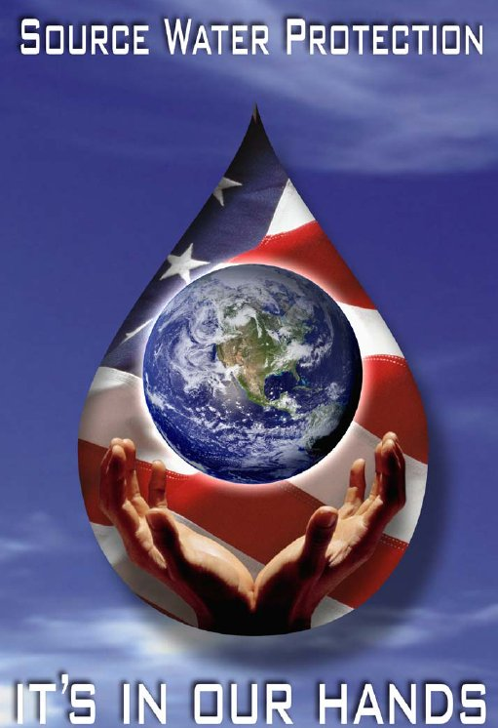
Wellhead Protection Plan
For the
Name of water system
PWSID# 0000xxx
Update Month 2005
TECHNICAL ASSISTANCE
PROVIDED BY



Table of Contents

Wellhead Protection Plan 1
Notification Roster 3
Contingency Plan 4
Method of Determination of Zone 2 and Zone 1 6
Zone 2 and Zone 1 Wellhead Protection Area 8
Aerial Photograph 9
Potential Contaminant Source Inventory 10
Well Pictures 12
Well #1 Pictures 13
Well #2 Pictures 15
Updates 17
Appendix A 18
Appendix B 19

Wellhead Protection Plan
Name of water system
P.W.S.I.D. NO. 0000xxx

The Name of water system has developed the following written policy to protect its Wellhead Protection Area and Management Areas.

- The Name of water system will not store, nor allow to be stored, any chemicals within the Zone 1 Wellhead Protection Area except for those chemicals used in the water treatment process.

- The Name of water system will not allow chemicals to be applied to the land within a minimum of 50 feet of their wells or springs. Signs will be placed near the Name of water system property that contains their wellfields which read “Wellhead Protection Area - Use chemicals according to the manufacturer’s label”. See Appendix A.

- In order to increase its available resources, the water system has furnished copies of the approved Wellhead protection plan to the following agencies to solicit support in implementing the Wellhead protection plan from these entities and to request review authority over any future changes to zoning laws and regulations which may affect the Wellhead protection areas:
Table 1
Agencies
Agency | Contact Name

- The Name of water system will actively observe the activities within the designated Wellhead Protection Area and report pertinent information to the Division of Water Resources Drinking Water Unit.

- The Name of water system will update the Potential Contaminant Source Inventory when changes occur within the Wellhead Protection Area.

- The Name of water system will update the Wellhead Protection Plan no less than every three (3) years by reviewing the Wellhead protection areas at least annually for any new potential contaminant sources. Each annual review will be maintained on file for the Sanitary Survey.

- The Name of water system will publish in their Consumer Confidence Report the required information concerning their Wellhead Protection Plan to provide public education.

- A Contingency Plan will be developed to establish the procedures to be implemented in the case of an emergency spill, which could impact the water source or the Wellhead Protection Area. This Contingency Plan is included in the Wellhead Protection Plan. In the case of an emergency spill which could impact the water source within the Wellhead Protection Area, the Name of water system will contact:

Division of Water Resources Drinking Water Unit
at (615) 532-0191
within 72 hours

Tennessee Emergency Management Agency
at 1-800-262-3300
within 24 hours

- Water System Information:
Table 2
^{Wellhead Contact Person} | ^{Position} | ^{Contact Phone Number} | ^{Contact e-mail}

 |  | TN
^{911 Address of Water Plant} | ^{City} | ^{State} | ^{Zip Code} | ^{County}

 |  | TN
^{Mailing Address of Water Plant} | ^{City} | ^{State} | ^{Zip Code} | ^{County}

Notification Roster
In the event a spill is reported to TEMA or the State of Tennessee, The phone numbers below can be used to contact the personnel at the Name of water system.
Table 3
Contact Name/Position | Phone Number #1 |  | Phone Number #2
 |  | ◻ Cell  ◻ Work  ◻ Home |  | ◻ Cell  ◻ Work  ◻ Home
 |  | ◻ Cell  ◻ Work  ◻ Home |  | ◻ Cell  ◻ Work  ◻ Home
 |  | ◻ Cell  ◻ Work  ◻ Home |  | ◻ Cell  ◻ Work  ◻ Home
 |  | ◻ Cell  ◻ Work  ◻ Home |  | ◻ Cell  ◻ Work  ◻ Home
 |  | ◻ Cell  ◻ Work  ◻ Home |  | ◻ Cell  ◻ Work  ◻ Home

Contingency Plan
Name of water system
P.W.S.I.D. NO. 0000xxx

Contingency Planning information provided by Name of water system is available in the State approved Emergency Plan and includes most items addressed below:

- Sources of drinking water currently available to the Public Water Supply:
  - The Name of water system utilizes the following water sources to supply drinking water to their customers:
Table 4
Water Sources

  - The Name of water system is connected to following water systems and would purchase water in the event of an emergency or spill within the Wellhead Protection Zone.
Table 5
Emergency Connections

  - In the case of failure of the water sources, the emergency procedures addressed in the emergency response plan will be utilized.

  - The Name of water system currently serves Enter number of water connections here.

- Quantity of water available from currently connected sources:
The water sources providing water for the Name of water system have an estimated maximum output:
Table 6
Source Name | GPM

- Additional water supplies that will meet future needs:
  - There are no written plans for future water supplies.
  - Other: Explain: Explain the plans for the addition of future water sources

- Actions that have been taken by local governments to protect designated future water supplies:
  - The local governments have taken no action to protect future water supplies.
  - The Name of water system has furnished copies of the approved Wellhead protection plan to agencies listed in Table 1(on page 1) of the Wellhead Protection Plan to solicit support in implementing the Wellhead protection plan from these entities and to request review authority over any future changes to zoning laws and regulations which may affect the Wellhead protection areas.

- Protection plans for designated future water supplies:
  - The Wellhead Protection Plan developed by the Name of water system prevents any chemicals not used for drinking water treatment from being stored adjacent to the wells or springs. Also, signs will be placed on the fences surrounding the plant and raw water wells or springs which read “Wellhead Protection Area – Use chemicals according to the manufacturer’s label”. The Name of water system monitors activities within this area and reports pertinent information to the Division of Water Resources Drinking Water Unit.

- Schedule for incorporation of designated future water supplies into the water system:
  - The Name of water system has no plans to add a new spring, well or intake to the system until there is a need.
  - The Name of water system will add a new spring, well or intake to the system on Enter the date the source will be put on-line

- Estimation of the resources necessary to incorporate designated future water supplies into the water system:
  - There are no plans to incorporate future water supplies at this time.
  - Plans to incorporate future water are attached

- Financial resources available to incorporate designated future water supplies into the water system:
  - In case of an emergency, the Name of water system would apply for any emergency grants or loans available to them.
  - Emergency grants or loans available are attached

- The Name of water system has entered into Mutual Aid Agreements with the following water systems and would be available to give and receive help in the event of an emergency or spill.
Table 7
Water System Aid Agreement is with | Type of service

- Enter the amount of The Name of water system Wellhead Protection Area that is covered by sanitary sewer:

◻ completely covered

◻ partially covered

◻ not covered

Method of Determination of Zone 2 and Zone 1
Name of water system
P.W.S.I.D. NO. 0000xxx

Description of System Wells or Springs
The Name of water system operates _____ ground water sources. The sources for the Name of water system are ______________________. The location of the sources are depicted on the delineation map.

Source Information
Name
Latitude
Longitude
USGS Quadrant Name
Depth of Well
Date Drilled
Drilling Company

ZONE 2
- The Zone 2 was determined using:
◻ WHPA software
◻ WHAEM software
WHPA/WHAEM Information
Transmissivity |  | ft²/d
Hydraulic Gradient |  | ft/ft
Angle of Flow |  | Degrees
Aquifer Porosity
Aquifer Thickness |  | ft

◻ Geologically Defined by the State of Tennessee
¨ Other Explain: ________________________________________________________

ZONE 1
- The Name of water system is considered a Category _____ as described in the Rules and Regulations. Zone 1 was determined by drawing a ________ foot radius circle around the ground water source.

Zone 2 and Zone 1 Wellhead Protection Area

Place map here

Aerial Photograph

Place map here

Potential Contaminant Source Inventory
Name of water system
P.W.S.I.D. NO. 0000xxx

The Potential Contaminant Source Inventory was conducted by _______________. The following people were contacted to obtain information for the inventory concerning any possible contamination of the groundwater they might be aware of:

Name | Agency

No contamination has occurred to their knowledge and no chemicals were being used that were not included in the inventory.

Each site listed in the inventory below is assigned a source number which is utilized to show the site on the map.

Potential Contaminant Source Inventory
Name of water system
P.W.S.I.D. NO. 0000xxx

(Don’t change the original source number)
Source Number | Facility Name | Facility Address | Latitude/Longitude | Comments

Well Pictures
Well #1 | Well #2
Well #3 | Well #4

Well #1 Pictures
North | Northeast
East | Southeast

Well #1 Pictures
South | Southwest
West | Northwest

Well #2 Pictures
North | Northeast
East | Southeast

Well #2 Pictures
South | Southwest
West | Northwest

Updates

Update Month and Year

1. Re-write of the Wellhead protection plan was conducted to meet all the current rules and regulations for Wellhead protection.
2. The potential contaminant source inventory was reviewed and updated.
3. New pictures were taken surrounding the wells
4. New maps provided showing each groundwater source and the potential contaminant sources was included
5. New aerial photographs were included.

I certify that the information provided in this Wellhead protection plan, potential contaminate source inventory and delineation of Wellhead protection area(s) is accurate to the best of my knowledge.

Signature of Wellhead protection contact person

Appendix A

WELLHEAD PROTECTION AREA

USE CHEMICALS ACCORDING TO THE MANUFACTURER’S LABEL

Appendix B

Annabelle Dempsey-Environmental Consultant
Drinking Water Unit
Division of Water Resources
Davy Crocket Tower, 9th Floor
500 James Robertson Pkwy, Nashville, TN 37243
Office: (615)-598-3947
Email: annabelle.dempsey@tn.gov

