Delete this Page
How to use this Guide

Word 97 - 2003 Computer Instructions
On your computer you will need to turn on the shaded field option by following these steps:
- Click on “Tools” from the menu.
- Click on “Options”.
- Under the “View” tab make sure that field shading says “Always” instead of the default setting of “When selected” by clicking on the arrow and choosing “Always” (See Picture Below).
- When updating the Plan just “Right Click” on the shaded fields and left click on “Update Field” and answer the question if prompted to do so.
- The “Table of Contents” will automatically update itself prior to printing.
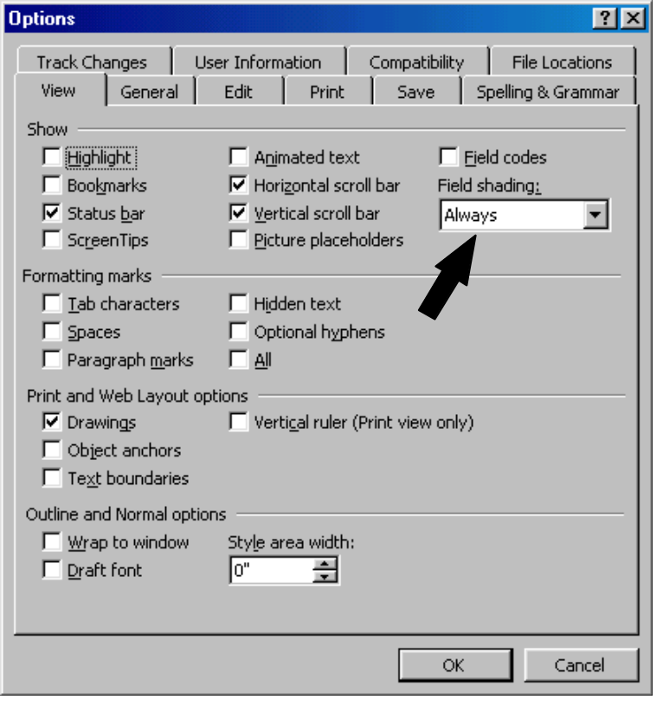
- Ensure that all fields are completed and correct prior to printing

How to use this Guide
Delete this Page

Word 2007 Computer Instructions
On your computer you will need to turn on the shaded field option by following these steps:
- Click on the “Office Button” in the top left corner.
- Click on “Word Options”.
- Click on “Advanced” on the left side of the window.
- Scroll down to the “Show document content” section.
- “Field shading” should show “Always”. If not, click the arrow and choose this option.
- The “Table of Contents” will automatically update itself prior to printing.
- Ensure that all fields are completed and correct prior to printing
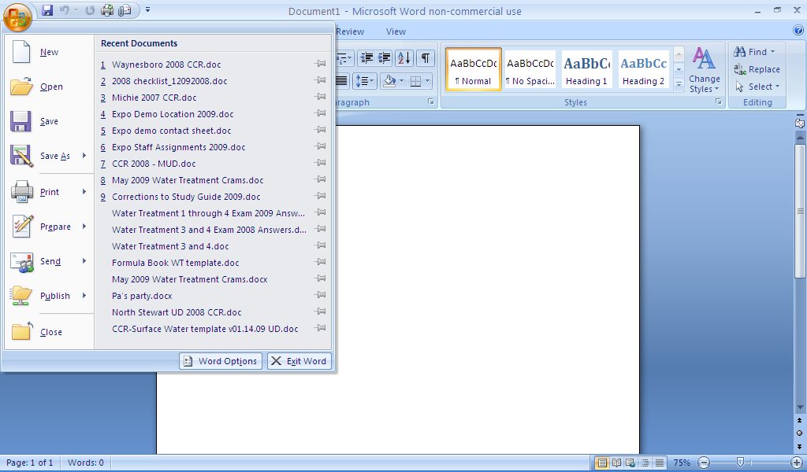
Step 1

Step 2

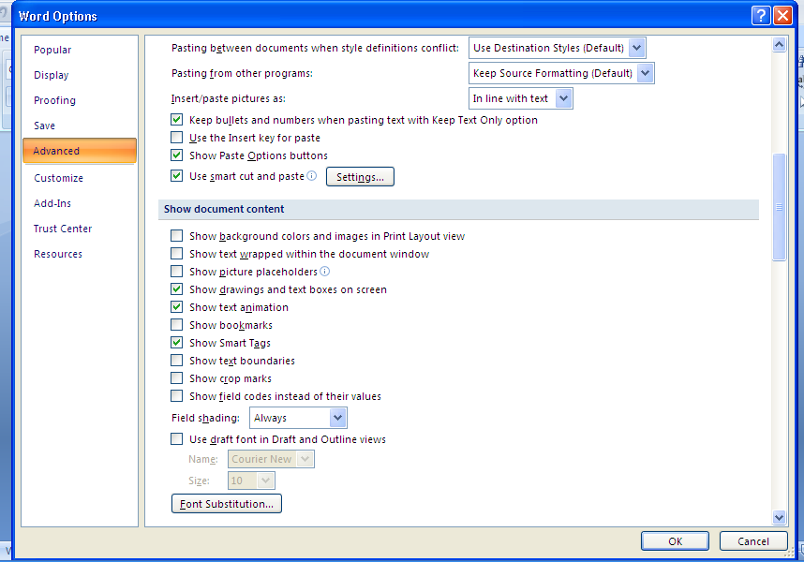

Step 3
Step 3

Step 5
Step 4

Delete this Page
How to use this Guide

Word 2013 Computer Instructions
On your computer you will need to turn on the shaded field option by following these steps:
- Click on “File” in the top left corner.
- Click on “Options”.
- Click on “Advanced” on the left side of the window.
- Scroll down to the “Show document content” section.
- “Field shading” should show “Always”. If not, click the arrow and choose this option.
- The “Table of Contents” will automatically update itself prior to printing.
- Ensure that all fields are completed and correct prior to printing

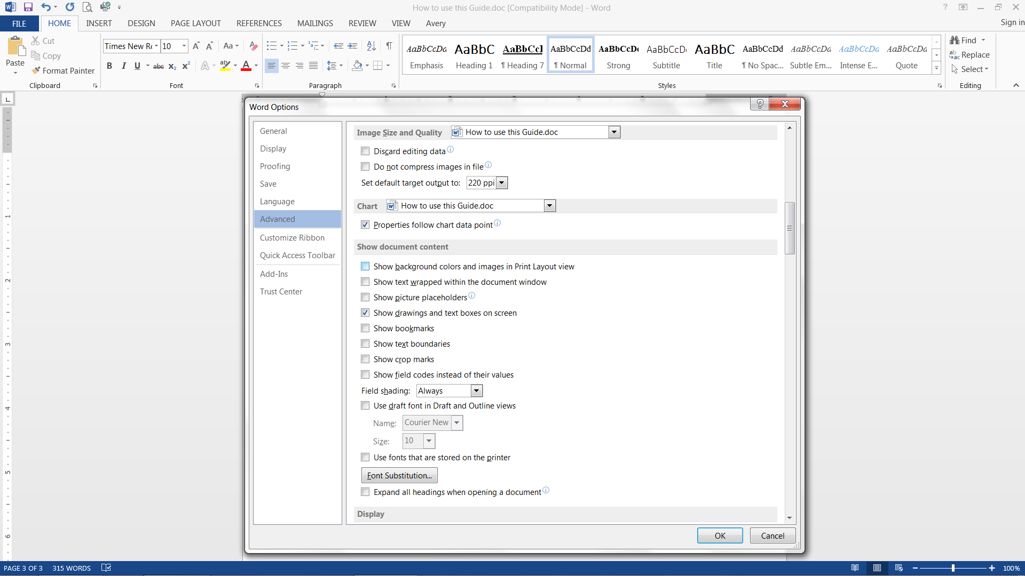

Delete this Page
Important

Using Fields
Once field shading is turned on, you will see fields in a gray box. Follow these steps to enter information:
- Left click on the field to move cursor to field.
- Right click on the field
- Left click on “update field”
- You should now see a window that explains what is to be entered.
- Type in your information.
- Left click “OK”
- The field should now be completed. Some fields are linked to others so that when you choose “update field” the information will be entered for you. If you do a print preview these will automatically update.

Hidden Text
Some instructions are listed in hidden text. To ensure that you can see hidden text follow these steps:

- Go to “Options” as before.
- Choose “Display”
- Check “Hidden Text” in the second section.
The hidden text will now be displayed on your computer but will not print.

Entering Sampling Sites in Tables
When entering sampling sites in the tables, if more rows are needed, push the “Tab” key in the last cell of the last row to add a new row.

Bacteriological Sampling Plan
For The

______________________

Last Updated: January 01, 2007

Prepared by the staff and management of the
______________________
Technical Assistance Provided By TAUD


Table of Contents

Objectives 7
General Information 8
Number of Samples Required 8
Sampling of New Lines and Following Line Repairs 8
Selecting Sampling Sites 10
System Map 12
Sampling Procedure 13
Faucets to Avoid 14
Actions to be taken if a Sample is Total Coliform-Positive 15
Dealing with Weekends and Holidays 16
What Triggers An Assessment 17
E.coli Maximum Contaminant Level (MCL) Violations 18
Actions to be taken if an E. coli-Positive Sample is involved in the Violation (A Violation Requiring a Tier 1 Public Notification) 18
Tier 1 PN for Violating the E. coli MCL 19
Treatment Technique Violations 20
Actions to be taken in the event of a Treatment Technique Violation (A Violation Requiring a Tier 2 Public Notification) 20
Tier 2 PN for Failure to Perform a Level 1 or 2 Assessment 21
Example of a Tier 2 PN for Failure to Perform Corrective Action 22
Monitoring and Reporting Violations 23
Actions to be taken in the event of a Monitoring/ Reporting Violation (A Violation Requiring a Tier 3 Public Notification) 23
Example Tier 3 PN for Failure to Take All Routine Total Coliform Samples in the Required Compliance Period 24
Example Tier 3 PN for Failure to Notify the State Following an EC+ Sample Result 25
Appendix A – Number of Samples Required 26
Appendix A – Number of Samples Required (continued) 27
Appendix B – Boil Water Notice Example 28
Appendix C – Level 1 ASSESSMENT FORM 29
Appendix D - Example of a Bacteriological Sampling Slip 37
Appendix E - Example of a Bacteriological Sampling Log 39

Objectives

The objective of this sampling plan is to ensure that samples for microbiological analysis be collected at sites, which are representative of the water throughout the distribution system. To meet this objective, sampling sites will include:

- Residential areas (at least 30%)
- Dead end lines
- Low use areas
- Commercial areas
- Areas near storage tanks

Samples will be distributed to ensure that no area served by the system is neglected during the year. The jurisdiction for selecting the sampling sites is to aid our operators in:
- Understanding the bacteriological quality of the water throughout the system
- Describing the quality of the water consumed by all the customers of the system

Special purpose samples are collected during repairs, in response to complaints, or for other maintenance reasons. Collection of these types of samples is necessary to ensure that coliform bacteria have not entered the distribution system as a result of events such as installation of mains, main line repair or routine maintenance. Special purpose samples cannot be included in compliance or assessment trigger calculations. Special purpose samples are collected in addition to any samples collected in accordance with this plan for compliance with the Revised Total Coliform Rule.

General Information

The official name and address for this system is

______________________

___________________________________

___________________________________

The PWSID (Public Water Supply Identification Number) number for this system is __________.

The water source for this water system is: ________________________

The population served by this system is _____________________.

This system is inspected by the ____________________ Environmental Field Office.

Number of Samples Required
The number of samples to be taken by this system is determined by the Department of Environment and Conservation, Division of Water Resources.

The number of routine samples this system is required to take by the Department of Environment and Conservation each month is ___________.

Our system can take the required number of samples, or more than is required. The number of samples our system will take is ___________.

The number of repeat samples required should a total coliform-positive occur is three.

The number of routine samples required for the month following a total coliform-positive sample is ___________.
(Any month following a month with a positive total coliform sample, systems on monthly sampling collect the normal number of routine samples)

Sampling of New Lines and Following Line Repairs

Bacteriological sampling of new lines and line repairs is explained in the system’s Standard Operating Procedure for line repairs.

The person(s) responsible for reporting to the Department:

_________________________________
_________________________________

Selecting Sampling Sites
(Instruction Sheet)
Delete this Page

The following pages in your plan describe how you intend to divide your system and distribute the sampling sites so that the objectives and requirements of your sampling plan are met. You are required to take samples in certain areas of your system and at certain types of service connections. The required sampling sites and number of samples are identified at the top of the page.

You can divide your system several ways, depending upon the number of required samples. For example, a system required to take one sample per month could divide into 12 sampling zones, taking one sample from each zone each month.

A system required to take 2 samples per month could divide into two sampling zones, taking one sample from each zone every month.

Under the RTCR, systems must list a physical address or GPS coordinates for each sampling site. You must list all sites in your sampling plan. You may wish to select enough sites for three months of routine sampling. This would allow you to use each site every quarter and then start back at the first site on the list. You should also list some alternate sites in case a routine site is unavailable for sampling.

Selecting Sampling Sites

- Coliform samples shall be collected at sites, which are representative of water throughout the distribution system according to a written sample-siting plan.
- The system must take at least 30% of the required samples from residential areas. For the purposes of this plan, residential areas are defined as locations in the distribution system which are served by the smallest distribution lines.
- The system must take at least some of the required samples from dead end lines, low use areas, and areas near large storage tanks.

(All primary and secondary sites should be selected at least one tap from the end of a line to allow for proper repeat sampling)

Primary Routine Total Coliform Sampling Sites:
Map ID # | Specific Addresses or GPS Coordinates | Zone

Alternate Routine Total Coliform Sampling Sites: (to be used if primary sites are not available)
Map ID # | Specific Addresses or GPS Coordinates | Zone

Our system has been divided into ________ sampling zones. If a primary sampling site is not available, an alternate sampling site will be selected from the same zone for routine monitoring.

If there is a total coliform or E. coli positive sample, repeat sampling will be conducted within 24 hours of notification at the following locations:
- The site of the original positive sample.
- Within five taps downstream of the original positive site.
- Within five taps upstream of the original positive site.

System Maps
Delete this Page
You will be required to have maps showing the sampling locations for your system. The maps will have to be of such detail as to show the sample locations.

System Map

Insert map here. Include the site ID numbers on the map.

Sampling Procedure

Review the system map and sampling plan to determine where and when samples are to be taken.
- After arriving at the sampling site, remove any attachments on the faucet. (Explain to the customer why this is done.)
- Turn the water on and let it run for several minutes to:
- Flush out the customer lines, and
- Ensure that the water being sampled is from the distribution lines, and not the customer’s plumbing.
  - (A thermometer can be used to determine when water is being drawn from the distribution system and not the customer’s plumbing. The water temperature will stabilize once all the water from the customer’s plumbing has been flushed out and the water flowing from the faucet is coming from the distribution system.)
- Adjust the flow from the faucet to a slow, steady stream.
- In a container, other than the one to be used for taking the bacteriological sample, take a sample of water flowing from the tap and determine the free chlorine residual.
- Open the container used to take the bacteriological sample.

Warning
Do not touch the inside of the bottle or lid.
Do not rinse the bottle out.
- Grasp the container near the bottom.
- Put the container under the flowing stream.
- Fill the bottle to the neck or indicated fill line.
- Remove the sample container from the flow as soon as it is filled.
SEAL THE CONTAINER IMMEDIATELY.
- Turn off the water and replace any attachments previously removed.
- Label the container.
- Complete the required forms using the following sample type codes:
- “D” = Regular or Routine Samples.
- “R” = Repeat Samples
- “S” = Special or Line Repair Samples.
- “N” = New Line Samples
- “F” = Fixed for line repairs
- Place the container and completed forms in the shipping box.
- Clean up the sampling site.
- Clean up any mess you might have made.
- Thank the customer for their cooperation.
- Make sure that the sample arrives at the lab within 30 hours from the time it was taken.

Faucets to Avoid

Avoid taking samples at these faucets if at all possible

If you can avoid these, be sure to use good sampling techniques.
- Outdoor Faucets
- Frost-proof Faucets

If you must take a sample from an outdoor faucet, use caution. Avoid dust, obvious contamination, splashing rain, snow and other possible sources of contamination, such as:
- An indoor faucet connected to a cistern, pressure tank, pump, softener, or water heater.
- A new faucet.
- A hot water faucet.
- A recently repaired faucet.
- Faucets with threaded taps.
- Mixing faucets.
- Faucets supplying dish water in cafes, drug stores, or other sites with a higher-than-usual possibility for bacterial contamination.
- Swing faucets.
- Faucets positioned close to a sink or the ground. (It must be high enough to keep it from touching the sampling container.
- Leaky faucets or faucets which allow water to seep around the valve stem.

What does this all mean? You should avoid any faucet, which will threaten to contaminate a sample. You will not always be able to avoid all these types of faucets. If you have to take a sample from one of these faucets, you should exercise extreme care and use good sampling techniques.

Actions to be taken if a Sample is Total Coliform-Positive

Should one of the routine samples be total coliform-positive, this system is required to take a set of three (3) repeat samples. The set of repeat samples will be taken as follows:
- At least one of the repeat samples must be taken from the sampling tap where the original total coliform-positive samples was taken;
- At least one of the repeat samples must be taken at a tap within 5 service connections downstream from the original sampling site;
- At least one of the repeat samples must be taken at a tap within 5 service connections upstream from the original sampling site;
- the complete set of repeat samples must be taken within 24 hours of the system being notified of a positive coliform result, or when instructed to sample by the Division of Water Resources;
- the entire set of repeat samples must be taken on the same day.

Should one of the repeat samples be positive, another set must be taken.

Repeat samples must be taken until:
- total coliforms are not detected in one complete set of repeat samples, or
- the system exceeds the total coliform treatment technique trigger during the month and notifies the State Department of Environment and Conservation, Division of Water Resources.

Dealing with Weekends and Holidays

Should repeat samples be required on a weekend or holiday, follow this procedure:

Routine samples will be taken on Mondays and Tuesdays to avoid a problem with repeat samples. This should allow ample time for repeat samples to be taken before the weekend if they are required. If a holiday should occur, which could cause a problem with either routine or repeat sampling, routine sampling will be postponed until the following week. Planning ahead, following these guidelines, should allow us to avoid any sampling problems associated with weekends or holidays.

Should it not be possible to collect repeat samples and submit them for analysis within the required 24-hour period because of a holiday or weekend, the system will provide for a “boil water notice” to be issued until sufficient samples can be collected and analyzed to verify that the contamination has been eliminated. Refer to Appendix B for an example of a “boil water notice”.

What Triggers An Assessment

Level One Assessment
A level 1 assessment is required to be conducted as soon as practical but no later than 30 days of the following events. A Division of Water Resources Level 1 Assessment form must be completed and submitted to the Division of Water Resources. Refer to Appendix E for Level 1 Assessment forms.

- For a system collecting 40 samples or more per month, more that 5.0% of samples are total coliform positive.
- For a system collecting fewer than 40 samples per month, more than one sample is total coliform positive.
- The system fails to take every required repeat sample following any routine total coliform positive sample.

Level 1 assessment for a CWS must be conducted by a licensed certified operator. ________________________ or other certified operator will conduct Level 1 assessments if a trigger is exceeded. A State approved Level 1 Assessment form must be completed and submitted to the Division of Water Resources within 30 days of the trigger exceedance. Any sanitary defects or deficiencies must be corrected within 30 days of the trigger exceedance or in accordance with an approved schedule from the Division of Water Resources.

Level Two Assessment
A level 2 assessment is required to be conducted as soon as practical but no later than 30 days of any of the following events:

- An E.Coli Maximum Contaminant Level (MCL) violation
- A second Level 1 assessment trigger within a rolling 12 month period.

Level 2 assessments for all systems must be conducted by a licensed operator who is certified to at least the same level as the public water system being assessed and who has completed an approved level 2 training certification course from the Division of Water Resources. A system serving a population of less than 50,000 must use a 3rd party assessor. ______________________ has made arrangements with ___________________________ operators who are qualified to conduct a level 2 assessment if needed.
A Division of Water Resources Level 2 Assessment form must be completed and submitted to the Division of Water Resources within 30 days of the trigger exceedance. Any sanitary defects or deficiencies must be corrected within 30 days of the trigger exceedance or in accordance with an approved schedule from the Division of Water Resources.

E.coli Maximum Contaminant Level (MCL) Violations

An E.coli MCL violation occurs when any of the following conditions exist.

- An E.coli positive repeat sample follows a Total Coliform positive routine sample.
- A Total Coliform positive repeat sample follows an E.coli positive routine sample.
- A system fails to take all required repeat samples (3) following an E.coli positive routine sample.
- A system fails to test for E.coli when any repeat sample tests positive for total coliform.

Actions to be taken if an E. coli-Positive Sample is involved in the Violation (A Violation Requiring a Tier 1 Public Notification)

If any repeat sample is E. coli -positive or any repeat sample following an E. coli-positive routine sample is total coliform-positive:
- Report the violation to the State no later than the end of the day when the system was notified of the results, unless the system is notified after the Department office is closed, in which case it must notify the State before the end of the next business day.
  - Person to Contact: ____________________ at the ____________________ Environmental Field Office. Telephone: ______________ or 1-888-891-8332

- Notify the public using this procedure:
- Furnish a copy of the notice to customers via direct delivery and or the local radio and television stations served by the public water system as soon as possible, but no later than 24 hours after the violation;
- Refer to the EPA Public Notification Handbook for specific content and delivery requirements. An example PN is contained on the following page.

    - The notice should contain the language shown in the example notice on the next page;
    - The system may want to describe what is being done to correct the problem:
      - Total number of samples taken,
      - Total number of positive samples,
      - Problem areas,
      - Mains are being flushed, etc.

- A Level Two Assessment must be conducted within 30 days of the E. coli positive sample.

Tier 1 PN for Violating the E. coli MCL

DRINKING WATER WARNING
E. coli is Present in ______________________ Water
BOIL YOUR WATER BEFORE DRINKING OR USING

Our water system detected E. coli bacteria in our distribution system. As our customers, you have a right to know what happened and what we are doing to correct this situation. On _________________, we learned that coliform bacteria were present and one of our routine samples collected on _________________, was total coliform-positive (TC+). As required by the Revised Total Coliform Rule, one of our follow-up steps was to collect repeat samples at and near the location where the TC+ sample was originally taken. One of these repeat samples collected on _________________ tested positive for E. coli. We are now conducting additional sampling to determine the extent of the problem and are conducting a thorough investigation to determine the source of the contamination.

What should I do?
DO NOT DRINK THE WATER WITHOUT BOILING IT FIRST. Bring all water to a rolling boil, let it boil for one minute, and let it cool before using it. Boiling kills bacteria and other organisms in the water. You may also use bottled water. Use boiled or bottled water for drinking, making ice, preparing food and washing dishes until further notice.
Also, if you have a severely compromised immune system, have an infant, or are elderly, you may be at increased risk and should seek advice about drinking water from your health care providers. General guidelines on ways to lessen the risk of infection by microbes are available from EPA’s Safe Drinking Water Hotline at (800) 426-4791. If you have specific health concerns, consult your doctor. We are also providing regular updates on this situation on ____________________.

What does this mean?
Inadequately treated or inadequately protected water may contain disease-causing organisms. These organisms can cause symptoms such as diarrhea, nausea, cramps and associated headaches. E. coli are bacteria whose presence indicates that the water may be contaminated with human or animal wastes. Human pathogens in these wastes can cause short-term effects, such as diarrhea, cramps, nausea, headaches, or other symptoms. They may pose a greater health risk for infants, young children, some of the elderly, and people with severely-compromised immune systems. These symptoms are not caused only by organisms in drinking water. If you experience any of these symptoms and they persist, you may want to seek medical advice.

What is being done?
We are conducting a thorough investigation to determine the source of the contamination and will be working with the State to implement corrective actions to ensure that our water supplies are protected against contamination. We will keep you informed of the steps we are taking to protect your drinking water and will provide information on any steps you should be taking. We will inform you when tests show no bacteria and you no longer need to boil your water. We are also providing regular updates on this situation on ____________________.

For more information, please contact _________________, __________ of ______________________ , at ______________ or write to ___________________________________________________________.

Please share this information with all the other people who drink this water, especially those who may not have received this notice directly (for example, people in apartments, nursing homes, schools and businesses). You can do this by posting this notice in a public place or distributing copies by hand or mail.
This notice is being sent to you by ______________________ State Water System ID# TN __________
Date Sent: _________________

Treatment Technique Violations

A treatment technique violation occurs when any of the following conditions occur.

- The system exceeds a treatment technique trigger and then fails to conduct an assessment or complete corrective actions within required timeframes.

Actions to be taken in the event of a Treatment Technique Violation (A Violation Requiring a Tier 2 Public Notification)

A public water system that has violated the treatment technique for total coliforms by failing to conduct an assessment, complete corrective actions or fails to complete the approved seasonal start up procedure must;

- Report the violation to the State no later than the end of the next business day after system learns of the violation.
Person to Contact: ____________________ at the ____________________ Environmental Field Office
Telephone: ______________ or 1-888-891-8332

- A Tier 2 Public Notice must be issued:
Tier 2 notices must be issued within 30 days of learning of the violation.

- Refer to the EPA Public Notification Handbook for specific content and delivery requirements. Examples are contained in the next two pages

- Notify the public using this procedure:
  - Furnish a copy of the notice to the customers served by the public water system via mail or other direct delivery as soon as possible, but no later than 30 days after the violation;
    - The notice should contain the language shown in the example notices on the next pages;
    - The system may want to describe what is being done to correct the problem:

Tier 2 PN for Failure to Perform a Level 1 or 2 Assessment

DRINKING WATER NOTICE
______________________ Failed to Conduct an Assessment of the Facility and Distribution System

Coliforms are bacteria that are naturally present in the environment and are used as an indicator that other, potentially harmful, waterborne pathogens may be present or that a potential pathway exists through which contamination may enter the distribution system. In one sample we collected on __________________, and one sample collected on __________________, we found coliforms, indicating the need to look for potential problems in water treatment or distribution. When this occurs, we are required to conduct an assessment to identify problems and to correct any problems that are found. We were required to conduct a Level 1 assessment within 30 days of learning of the second total coliform-positive (TC+) sample. A Level 1 assessment is a study of the water system to identify potential problems and determine (if possible) why total coliform bacteria have been found in our water system. As our customers, you have a right to know what happened and what we are doing to correct this situation. As required by the Revised Total Coliform Rule, we failed to conduct the required Level 1 or 2 assessment within 30 days, and have therefore, violated a requirement of the Revised Total Coliform Rule.

What does this mean?
This is not an emergency. If it had been an emergency, you would have been notified within 24 hours.
Failure to conduct an assessment to identify the sanitary defect that triggered the assessment has the potential to cause distribution system contamination. Inadequately treated or inadequately protected water may contain disease-causing organisms. These organisms can cause symptoms such as diarrhea, nausea, cramps, and associated headaches. Failure to perform the assessment prolonged the risk of fecal contamination of our distribution system water. While we have not detected any evidence of fecal contamination in our distribution system, we are committed to correcting the deficiency to eliminate the potential threat of contamination.

What should I do?
- You do not need to boil your water or take other corrective actions. However, if you have specific health concerns, consult your doctor.
- If you have a severely compromised immune system, have an infant, are pregnant, or are elderly, you may be at increased risk and should seek advice from their health care providers about drinking this water. General guidelines on ways to lessen the risk of infection by microbes are available from EPA’s Safe Drinking Water Hotline at (800) 426-4791.
You do not need to boil your water or take other corrective actions. If a situation arises where the water is no longer safe to drink, you will be notified within 24 hours. We will announce any emergencies on ____________________.

What is being done?
We have since completed the Level 1 assessment and identified the cause of the sanitary defect; damage to the storage tank. We are implementing the corrective action plan established by the State. Under this plan, the damage will be repaired.

For more information, please contact ____________________, ___________________ of ______________________, at ____________ or write to ___________________________________________________.

Please share this information with all the other people who drink this water, especially those who may not have received this notice directly (for example, people in apartments, nursing homes, schools and businesses). You can do this by posting this notice in a public place or distributing copies by hand or mail.
This notice is being posted by ______________________ State Water System ID# TN __________. Sent: __________

Example of a Tier 2 PN for Failure to Perform Corrective Action

DRINKING WATER NOTICE
______________________ Failed to Perform Corrective Action Following an Assessment of the Facility and Distribution System

Coliforms are bacteria that are naturally present in the environment and are used as an indicator that other, potentially harmful, waterborne pathogens may be present or that a potential pathway exists through which contamination may enter the distribution system. We found coliforms, indicating the need to look for potential problems in water treatment or distribution. When this occurs, we are required to conduct assessment(s) to identify problems and to correct any problems that are found. This past summer, we were required to conduct a Level 1 assessment. We completed the required Level 1 assessment and identified the cause of the sanitary defect to be ________________________________. While we failed to correct the sanitary defect within the required timeframe, we are implementing the corrective action plan established by the State. As our customers, you have a right to know what happened and what we are doing to correct this situation. As required by the Revised Total Coliform Rule, we failed to complete the corrective action within the required timeframe, and have therefore, violated a requirement of the Revised Total Coliform Rule.

What does this mean?
This is not an emergency. If it had been an emergency, you would have been notified within 24 hours.
Failure to correct the identified defect that was found during the assessment has the potential to cause distribution system contamination. Inadequately treated or inadequately protected water may contain disease-causing organisms. These organisms can cause symptoms such as diarrhea, nausea, cramps, and associated headaches.

What should I do?
- You do not need to boil your water or take other corrective actions. However, if you have specific health concerns, consult your doctor.
- If you have a severely compromised immune system, have an infant, are pregnant, or are elderly, you may be at increased risk and should seek advice from their health care providers about drinking this water. General guidelines on ways to lessen the risk of infection by microbes are available from EPA’s Safe Drinking Water Hotline at (800) 426-4791.
You do not need to boil your water or take other corrective actions. If a situation arises where the water is no longer safe to drink, you will be notified within 24 hours. We will announce any emergencies on ____________________.

What is being done?
Since being informed of the failure, we have begun to correct the sanitary defect identified during the Level 1 assessment. During the assessment, the sanitary defect was determined to be ___________________________________. We are in communication with the State and have modified the corrective action plan’s schedule to repair and disinfect the storage tank.

For more information, please contact ____________________, _______________ of ______________________, at _____________ or write to ___________________________________.

Please share this information with all the other people who drink this water, especially those who may not have received this notice directly (for example, people in apartments, nursing homes, schools and businesses). You can do this by posting this notice in a public place or distributing copies by hand or mail.
This notice is being posted by ______________________. State Water System ID# TN __________. Sent: _____________

Monitoring and Reporting Violations

A Monitoring or Reporting violation occurs when any of the following conditions exist.

- A system fails to collect all routine or additional routine samples
- A system fails to take/analyze for E-coli after a total coliform positive routine.
- A system fails to submit a monitoring report, assessment report or certification of start- up procedure completion.
- A system fails to notify the State of an E.coli positive sample.

Actions to be taken in the event of a Monitoring/ Reporting Violation (A Violation Requiring a Tier 3 Public Notification)

A public water system that has violated the Monitoring and or Reporting requirements must;

- Report the violation to the State no later than the end of the next business day after system learns of the violation.
- Person to Contact: ____________________ at the ____________________ Environmental Field Office
  - Telephone: ______________ or 1-888-891-8332
- A Tier 3 Public Notice must be provided to customers:
- Tier 3 notices must be issued within 360 days of learning of the violation.
- Refer to the EPA Public Notification Handbook for specific content and delivery requirements. Examples are contained in the next two pages
- Notify the public using this procedure:
  - Furnish a copy of the notice to the customers served by the public water system via mail or other direct delivery as soon as possible, but no later than 365 days after the violation;
    - The notice should contain the language shown in the example notices on the next pages;
- The system may want to describe what is being done to correct the problem:

Example Tier 3 PN for Failure to Take All Routine Total Coliform Samples in the Required Compliance Period

IMPORTANT INFORMATION ABOUT YOUR DRINKING WATER
Monitoring Requirements Not Met for System D

We are required to monitor your drinking water for specific contaminants on a regular basis. Results of regular monitoring are an indicator of whether or not your drinking water meets health standards. During __________________, we did not complete all monitoring or testing for total coliform, and therefore, cannot be sure of the quality of your drinking water during that time.

On __________________, we became aware that our water system failed to collect all of the required monthly routine total coliform distribution system samples in __________________. Although this incident was not an emergency, as our customers, you have a right to know what happened and what we did to correct the situation. None of the _____ samples that we did collect was positive for total coliform or E. coli bacteria.

What should I do?
There is nothing you need to do. You do not need to boil your water or take other corrective actions. You may continue to drink the water. If a situation arises where the water is no longer safe to drink, you will be notified within 24 hours. We will also announce any emergencies on ____________________.

What was done?
We collected all _____ of the required routine total coliform samples in ___________ and tested them for E. coli. None of the samples collected in ___________ was positive for E. coli.

For more information, please contact ____________________, _______________ of ______________________, at _____________ or write to ___________________________________.

Please share this information with all the other people who drink this water, especially those who may not have received this notice directly (for example, people in apartments, nursing homes, schools and businesses). You can do this by posting this notice in a public place or distributing copies by hand or mail.

This notice is being posted by ______________________. State Water System ID# TN __________. Sent: __________

Example Tier 3 PN for Failure to Notify the State Following an EC+ Sample Result

IMPORTANT INFORMATION ABOUT YOUR DRINKING WATER
Reporting Requirements Not Met for System F

Our system failed to notify the state of an E. coli-positive (EC+) routine sample by the end of the day that we learned of the violation. The water system has not exceeded the E. coli MCL standard set by the Revised Total Coliform Rule. Although this incident was not an emergency, as our customers, you have a right to know what happened and what we did to correct the situation.

What should I do?
There is nothing you need to do. You do not need to boil your water or take other corrective actions. You may continue to drink the water. If a situation arises where the water is no longer safe to drink, you will be notified within 24 hours. We will also announce any emergencies on ____________________.

What was done?
We notified the state of the routine monitoring sample that was EC+.

For more information, please contact ____________________, _______________ of ______________________, at _____________ or write to ___________________________________.

Please share this information with all the other people who drink this water, especially those who may not have received this notice directly (for example, people in apartments, nursing homes, schools and businesses). You can do this by posting this notice in a public place or distributing copies by hand or mail.

This notice is being posted by ______________________. State Water System ID# TN __________. Sent: __________

Appendix A – Number of Samples Required

The method used to determine the required number of samples is listed here.

The population served by the system is equal to the number of service connections times the household factor for the area served by the system.

- The household factor for this system is __________. This number can be obtained from the local Health Department, the Basin Office, or the Department of Environment and Conservation in Nashville.
- The number of service connections served by this system is ___________.
- The population served by this system is _________.
- According to the table on the next page, the required number of samples per month is ______________.
- If the number of routine samples required by your calculations differs from that required by the State, you should contact the Department of Environment and Conservation for a final determination of the number of routine samples required.

Appendix A – Number of Samples Required (continued)

1200-5-1-.07 (c) The supplier of water for a community water system shall take coliform samples at regular time intervals and in numbers proportional to the population served by the system during the reporting period as set forth below:

TOTAL COLIFORM MONITORING FREQUENCY FOR COMMUNITY WATER SYSTEMS

Population Served | Minimum Number of Samples Per Month
25 to 1,000 | 1
1,001 to 2,500 | 2
2,501 to 3,300 | 3
3,301 to 4,100 | 4
4,101 to 4,900 | 5
4,901 to 5,800 | 6
5,801 to 6,700 | 7
6,701 to 7,600 | 8
7,601 to 8,500 | 9
8,501 to 12,900 | 10
12,901 to 17,200 | 15
17,201 to 21,500 | 20
21,501 to 25,500 | 25
25,501 to 33,000 | 30
33,001 to 41,000 | 40
41,001 to 50,000 | 50
50,001 to 59,000 | 60
59,001 to 70,000 | 70
70,001 to 83,000 | 80
83,001 to 96,000 | 90
96,001 to 130,000 | 100
130,001 to 220,000 | 120
220,001 to 320,000 | 150
320,001 to 450,000 | 180
450,001 to 600,000 | 210
600,001 to 780,000 | 240
780,001 to 970,000 | 270
970,001 to 1,230,000 | 300
1,230,001 to 1,520,000 | 330
1,520,001 to 1,850,000 | 360
1,850,001 to 2,270,000 | 390
2,270,001 to 3,020,000 | 420
3,020,001 to 3,960,000 | 450
3,960,001 or more | 480

Appendix B – Boil Water Notice Example

Press Release for Boil Water Notice

Due to ___________________________, we have reason to suspect that the water distributed to the customers of the ______________________ may be contaminated. Until further notice, water customers are advised to boil water prior to using it for drinking or food preparation. As a precaution, customers should take the following steps:

- Prior to boiling, the water should be strained through a clean cloth to remove any sediment or floating material.

- The water should then be heated to a vigorous boil, and the rolling boil should be maintained for one minute to insure disinfection.

Appendix C – Level 1 ASSESSMENT FORM

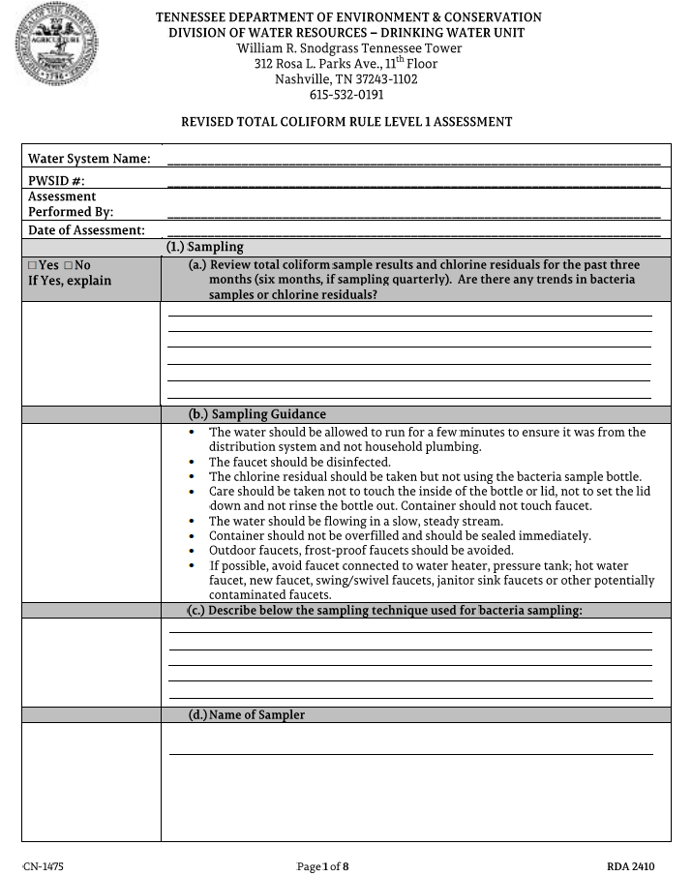

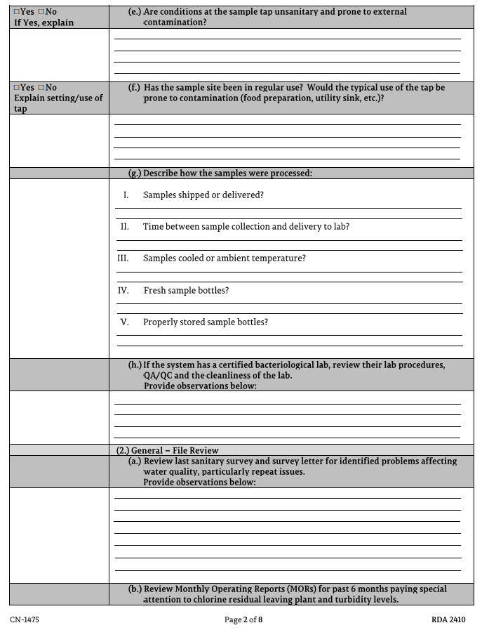

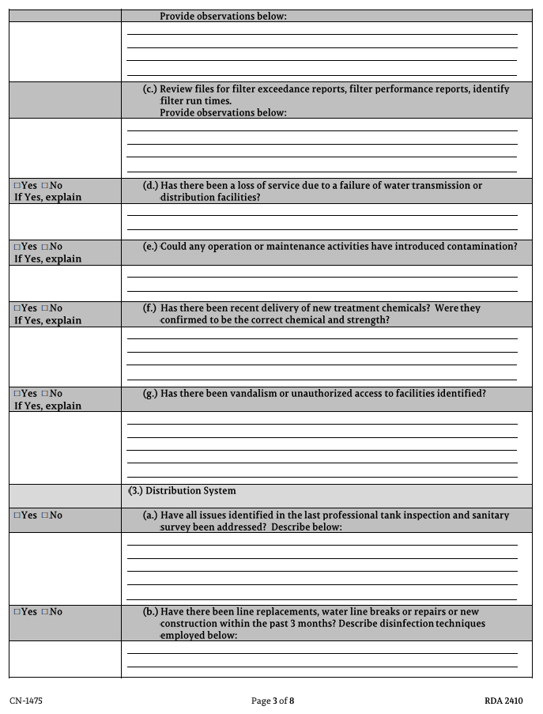
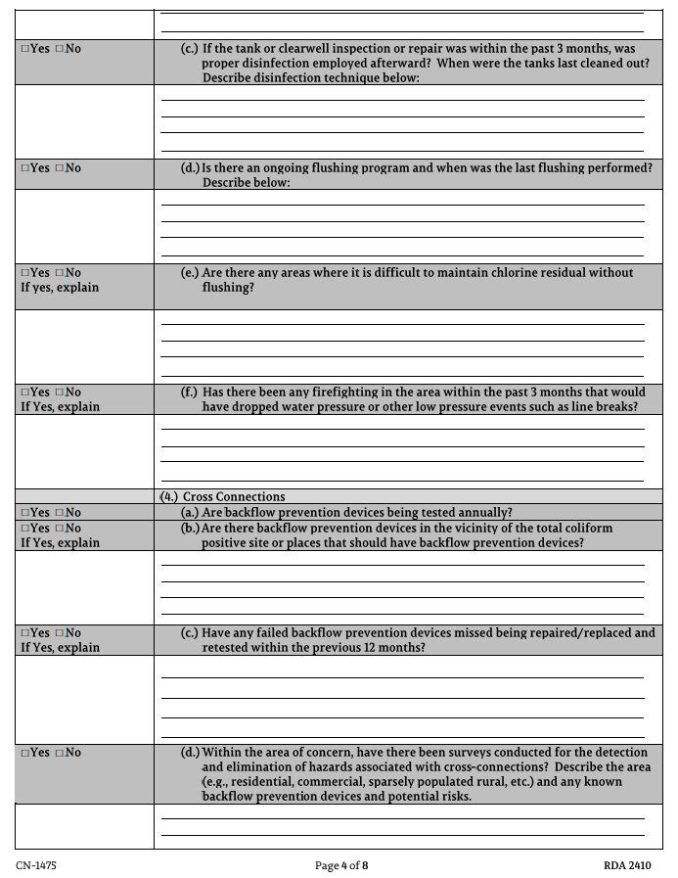
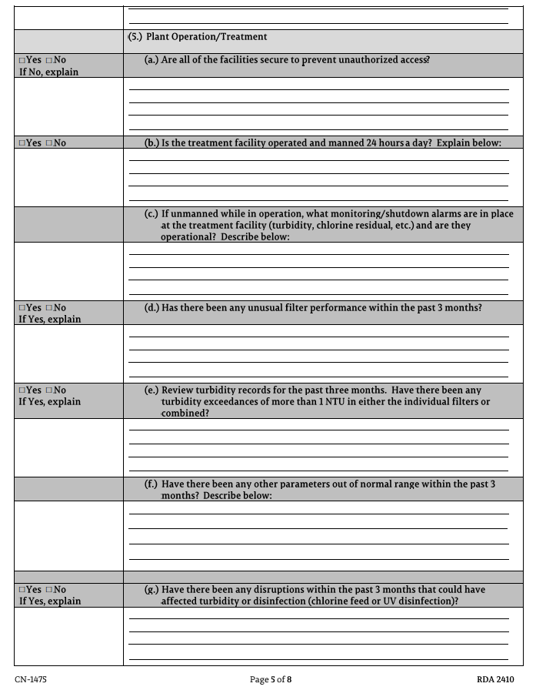
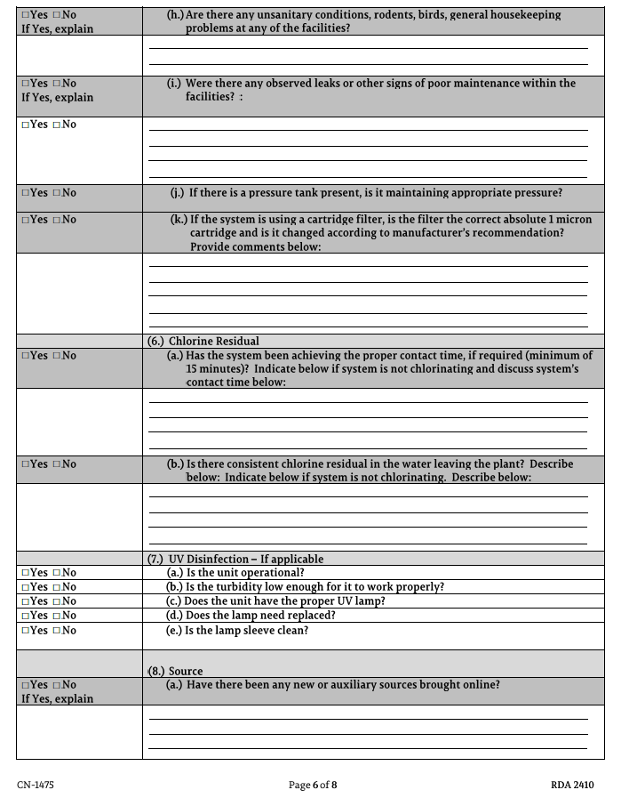
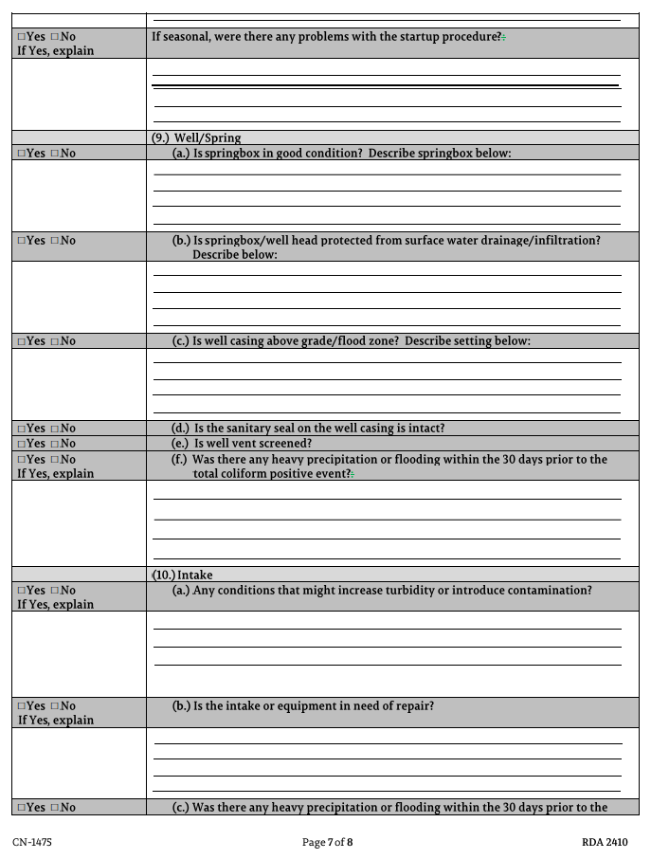
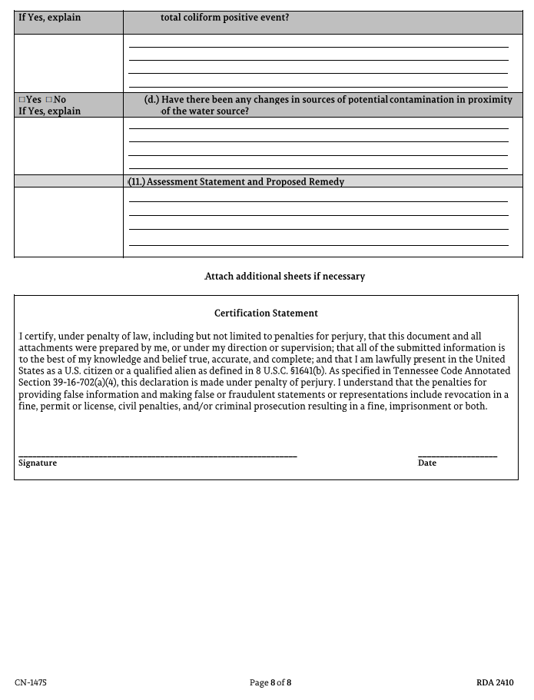

Appendix D - Example of a Bacteriological Sampling Slip
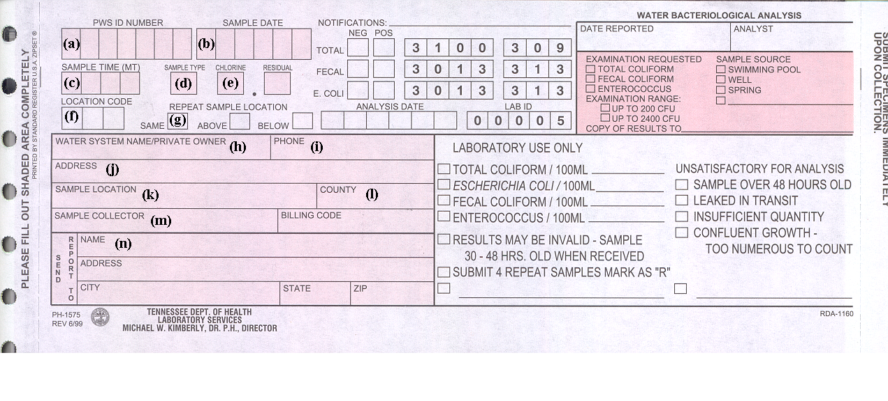
- PWSID number. XXXX Water System’s PWSID # is 0000XXX. In order to get credit for the sample, the PWSID number must be correct.

- Sample date. Record the date the sample is collected. Example: August 22, 2002 would read 082202.

- Sample time. Record the time of day in military time. 8:30 a.m. would be recorded as 0830. 1:30 p.m. would be recorded as 1330.

- Sample type. Sample types are recorded as follows:

D – Routine
R – Repeat
N – New lines
S – Special
Q – Quality Control
F – Fix or Repair

Failure to record the correct sample type can result in a monitoring requirement violation. Most samples will be coded as a “D” for a routine sample. Follow-up samples immediately following a positive routine sample are repeat samples and are coded as “R”.

- Chlorine Residual. All systems that disinfect their water must record the chlorine residual when coliform samples are collected. Chlorine residuals should be reported to the nearest one tenth of a milligram per liter or one tenth of a part per million.

- Location code. This 3-digit block would only be used when repeat samples are collected. The laboratory will furnish the numbers to be put in these blocks.

- Repeat Sample Location. Same Above Below Only used when collecting repeat “R” samples.

- Water System Name/Private Owner. Provide the name of the Water System or Utility District where the sample was collected.

- Phone. Provide a daytime telephone number to be called by the laboratory if they need to contact you about the sample.

- Address. Provide the complete mailing address of the Water System from which the sample was collected.

- Sample Location. Provide sufficient information so that you can return to the sample site for repeat samples if necessary and sufficient information that the sample site can be identified on your sampling site plan.

- County. Record the county where the public water system is located.

- Sample Collector. Record the name of the person who actually collected the sample.

- Name, Address, City, Zip. Please record the full address of the person or organization the coliform sample results should be mailed to. Make sure that this information is printed clearly because the laboratory uses this information to return the results to you.

Appendix E - Example of a Bacteriological Sampling Log

______________________

Bacteriological Sample Log

Date  Sample Taken  MM/DD/YY | Time Sample  Taken  (Military time) | Sample Location  (Describe, i.e.  Cedar Lodge  Kitchen Sink) | Chlorine Residual | Date  Sample  Mailed  MM/DD/YY | Date Sample  Results  Reviewed | Sample  Results  Positive (+)  Negative (-) | If Sample *  Results +,  Repeat Samples  Taken (Yes=Y) | Date  Public  Notice  Given

Military Time

8:30 a.m. is 0830 in MT (essentially clock time) *Show Date, Time, Place, and provide for Results of
1:30 p.m. is 1330 in MT (clock time plus 12) each repeat sample taken on this log.

